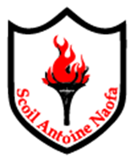
St. Anthony’s Boys’ National School
Application for Enrolment/Admission

Junior Infants 2020-2021 Intake

Child’s Name:
Date of Birth: |  | Please attach proof of D.O.B.
Address:
Phone Contact(s):
Email Address(es):
Guardian 1/Mother: |  |  |  | Is Father a Past Pupil? Yes No
Guardian 2/Father:
Child living in Ballinlough Parish? | Yes No |  | (If a place is offered then proof of address will be required in the form of a Utility Bill in a parent’s name from within three months)
Names of brothers currently enrolled in St. Anthony’s Boys’ National School:
Names of brothers who are past pupils of St. Anthony’s Boys’ National School:
2026-2027 Intake:

Signed by:

Date:
Date:

Please note the following:
- This form is an application to express interest in a place for your son in St. Anthony’s Boys’ National School. It does not guarantee that a place will be offered.

